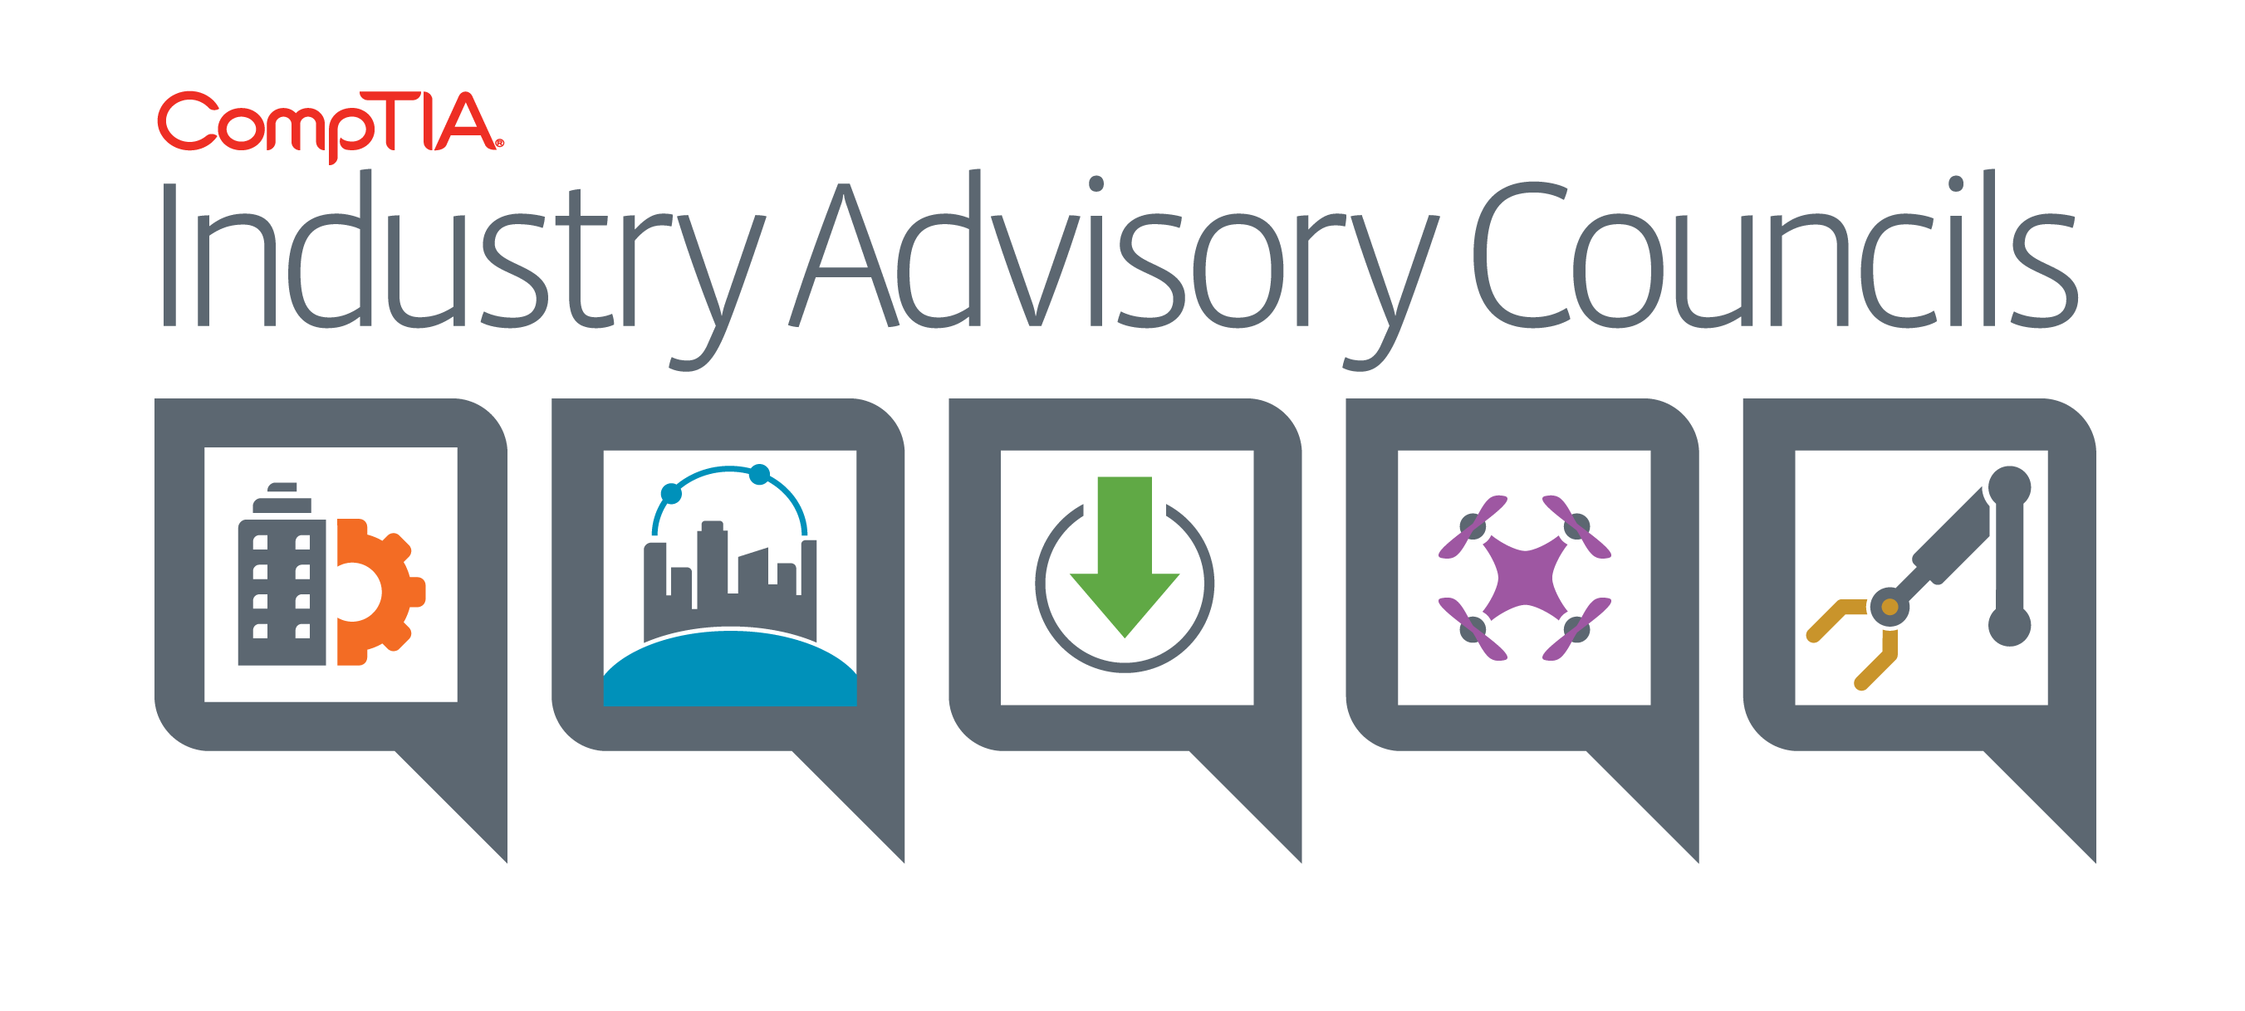
Meeting Minutes

Industry Advisory Councils – Spring Working Meeting
March 13-15th, Westin DFW Airport, Dallas, TX

There is no video recording for face to face meetings.
Attendees:
Smart Cities Advisory Council | Channel Advisory Board
Robert Senatore – Data2Go Wireless (Co-Chair)  Tricia Shevlin – THINaër (Vice Chair)  Robert Forget – Aware360  Glenn Morris – BuildingDNA  Drone Advisory Council  Enrico Schaefer – Drone Law Pro (Vice Chair)  Frank Segarra III – ConnexiCore (Co-Chair)  Jon Tull – Dronifi (Co-Chair)  Cory Dixon – College of Engineering and Applied Science University of Colorado, Boulder  Adam Gittins – HTS-AG  Eric Jameson – Stampede Global  Business Applications Advisory Council  Marc Haskelson – Compliancy Group LLC (Co-Chair)  Rakesh Mahajan – Smartsheet (Co-Chair)  Darren Bibby – DocuSign  Gavin Gamber – Connectwise  Kevin Layton – Data Dynamix  Sherrick Murdoff – Salesforce  Nate Olsen – Insperity  Nellie Scott – SAS  Manuel Valencia – Connective Agency | Steve Mungall – RedHat (Co-Chair)  Chad Paalman – NuWave Technology Partners (Vice Chair)  Ryan Walsh – Pax8 (Co-Chair)  Amy Bailey – Telarus  Rob Butler – Cross Vergence  Jason Bystrak – eFolder  Sandra Glaser Cheek – Ciena  Brain Davis – Tech Data Corporation  Tony Francisco – CloudPlus  Robert MacFarlane – Mosaic 451  John Kirkke – Onward Computer Systems  Jason McNew – Stronghold Cyber Security  Tim Norman – STL Technology Partners  Eric Pinto – Cytracom Inc.  Arlin Sorensen – HTSAG / HTG Peer Group  Meg Toups – BlueSky IT Partners, LLC  CompTIA Staff  Andrea Cutter, Marketing  Dean Galbreath, Membership  Rob Cosentino, Membership  Jim Hamilton, Communities  David Logsdon, Policy & Advocacy  Nancy Hammervik, Industry Relations  Miles Jobgen, Education  Dyan Page, Marketing  Chris Phillips, Industry Advisory Councils  Annette Taber, Industry Advisory Councils  Kimaya Wentworth, Industry Advisory Councils

INFORMATION CONTAINED IN THESE MINUTES IS CONFIDENTIAL AND PROPRIETARY TO COMPTIA. THESE MINUTES ARE INTENDED SOLELY FOR C OMPTIA’S INDUSTRY ADVISORY COUNCIL MEMBERS AND ARE NOT TO BE SHARED WITHOUT THE PRIOR WRITTEN CONSENT OF COMPTIA.

Thursday, March 14th, Welcome and Meeting Opening
Annette welcomed everyone to the meeting, covered the Anti-Trust Guidelines, and reviewed the agenda for both Wednesday and Thursday.

Wednesday, March 14th
- Welcome, Annette Taber, VP Industry Outreach
- CompTIA Update: David Logsdon, Sr. Director, Advocacy & Nancy Hammervik, EVP Industry Relations
- Lightning Round Introductions
- Meeting Outcomes: Jim Meffert, Sr. Consultant, Tecker International
- Individual Council Meetings
- Council Engagement Meetings
- Dinner at Hard Eight Pit BBQ

Thursday, March 15th
- Breakfast & Council Update, Annette Taber
- Individual Council Meetings
- Report Outs
- Meeting Wrap up and Close

Mission and Objectives for 2018 Industry Advisory Councils

Mission:
- Understand New Emerging Technology Ecosystems
- Identify and Develop Industry Best Practice Standards
- Educate, Collaborate and Drive Adoption of Emerging Technologies into Mainstream Business
- Stay informed on CompTIA’s Policy & Advocacy Efforts

Objectives:
- Expand CompTIA’s footprint and engagement with the broader ecosystem of business technology players
- Enable the IT Channel to understand, adopt, and grow product and service portfolio’s with new and emerging technologies and partners
- Educate emerging technology sectors on the value of the IT channel as a potential new route to market

- Policy Update – David Logsdon, Sr. Director, Advocacy (See 2018 Federal Policy Priorities Doc)
      - Smart Cities and Communities Act of 2017
      - The Smart Technology for Resilient, Efficient, Economic and Reliable Transportation in Cities and Communities Act (STREET Act)
      - Congressional Smart Cities Caucus
      - Drones & Proposed Federal Drone Legislation from 2017
      - Drone and Autonomous Vehicles State Legislation 2017
      - BlockChain
      - Autonomous Vehicles
      - Digital Infrastructure

- CompTIA 2018 Goals – Nancy Hammervik, EVP Industry Relations
Nancy reviewed CompTIA’s 2018 goals and reinforced the importance of CompTIA’s Industry Advisory Councils and the role they will play in CompTIA’s expansion (Membership, Research, Education, Certifications, etc.) into new emerging technology sectors. See attached for CompTIA Goals.

- Introductions – Chris Phillips, Director Industry Advisory Councils
Chris hosted our lightning round introductions and asked each council member to share the council they represent, name, title, company, two areas of expertise and what they want to learn more about. CompTIA staff members captured the responses on flip charts for each council. CompTIA’s marketing team will create Infographics from the responses to be posted on each Council Website.

- Outcomes for the Meeting – Jim Meffert, Sr. Consultant, Tecker International
- Jim shared the three levels of discussion surrounding our Council Meetings
        - Environmental Scan
        - Setting Goals
        - Prioritizing to achieve those goals
      - He then shared the outcomes we are hoping to obtain:
        - Review of the Environment, Barriers, and Accelerators
        - Goals for each Council
        - Making a connection between the Council Goals and
        - CompTIA’s Goals
        - Reviewing Strategies
        - Recommended Changes/Additions to the Council
        - Identify Methods to Measure Progress Toward Goals

- Individual Council Meetings
Individual Council Meetings took place from 10:15 am and went into late afternoon providing time for the Chairs of each Council to cover the following activities:
- Introductions again, this time with more focus what each council member is looking for out of their experience with CompTIA.
- With this being the first meeting of the newly formed CAB, SCAC and DRAC, it was important to get everyone on the same page. So we started with understanding common trends, barriers and accelerators to adoption, vision for the next 3-5 years, council goals, strategies to achieve the goals prioritized based on breadth of impact, consequence of depth of impact, immediacy and likelihood of success.
- Council members were asked to include additional perspectives of potential new members to add to the councils, and other sources of input needed for success.

- Council Engagement Meetings
CompTIA paired up each Council with a “sister” Council to see what synergy and collaboration might result. Councils were advised to share the results of their previous discussions and identify common themes of intersection and/or divergence.
      - Channel Advisory Board (CAB) met with Business Applications Advisory Council (BAAC)
      - Drone Advisory Council (DRAC) met with Smart Cities Advisory Council (SCAC)

- Networking Dinner
Buses left at 6:00 and 6:15pm to take our Council Members to a private dining room for our Networking Dinner at Hard Eight Pit BBQ

- Thursday, March 15th, Breakfast and Meeting Opening
Annette kicked off the meeting, covered the Anti-Trust Guidelines, shared results from our 2017 Annual Council Survey, and reviewed the agenda for Thursday.
- Individual Council Meetings
- Report Outs, Lunch and Group Discussion
- Wrap up and Close

- 2017 Council Accomplishments
- Launched Drone Advisory Council. Recruited 8 Drone Executives to sit on the council, all of whom were new to CompTIA.
- Expanded Business Applications Advisory Council. Recruited 11 Executives to sit on the Council, nine of whom were new to CompTIA
- Restructured IT Councils (VAC, DAC, PAC) into newly launched Channel Advisory Board with 28 members
- Automated onboarding of council members, charity process selection, and council lifecycle emails.
- Produced four Council Video’s
- Internet of Things
- Millennials in the Workplace
- Transparency in the Workplace
- Culture in the Workplace
- Launched “Tech Careers Awareness Campaign”
- Launched “CompTIA Speaker’s Bureau”
- Redesigned Web Presence for Industry Advisory Councils
- Made initial outreach to Robotics industry
- Hired Chris Phillips Director, Industry Advisory Councils
- Promoted Kimaya Wentworth to Sr. Specialist, Industry Relations Group

- 2017 Council Survey Results
  - Overall, how do you rate your experience with this council during your term on it? - Net Positive = 100%
  - CompTIA Council Meetings allow for the engagement of all perspectives in discussion, debate, & thought leadership - Net Agree = 100%
  - I receive personal & professional value from my engagement with CompTIA Industry Advisory Councils - Net Agree = 96%
  - My particular Advisory Council helped educate CompTIA and the broader industry through the sharing of thought leadership. - Net Agree = 84%
        - Feedback indicates a need to be more purposeful and action oriented (e.g. goals, plans, collaboration, participation)

- CompTIA Update
  - 2018 IT Industry Outlook Report – 12 Forces Shaping the Tech Industry. Download it now at http://Comptia.org/itoutlook18
  - Tech Talent, powered by CompTIA – Land your dream job, secure skilled talent, get the latest intel on the tech job market. Learn more at http://comptia.org/insight-tools/techtalent
  - CompTIA Channel Changer nominations due May 30th. Nominate a young, up and coming leader within your company. Honorees to be recognized at ChannelCon 2018. For more details visit http://Comptia.org/channelchangers
  - CompTIA Member of the Year nominations due before May 15th. Nominate an outstanding industry peer. Read more at http://comptia.org/MOTY
  - ChannelCon18. The Business of Technology. If your business builds, sells, influences, or drives adoption of technology, ChannelCon is the one event you don’t want to miss this year! Register today at http://comptia.org/ChannelCon

- Individual Council Meetings.
Annette reviewed the Council Mission and provided instruction to the Council Members before dismissing the group to participate in their Individual Council Meetings where each council was asked to:
  - Finalize their Discussions from the previous day
  - Prepare their Report Out Slide Decks

- Smart Cities Advisory Council (SCAC) Report Out

- Definition of a Smart City/Community - Utilizing digital technology and secure data to create knowledge and take action for citizen services.

Communities | Communications
Environmental Issues | Critical Infrastructure
Infrastructure | Parks and Rec
Transportation | Built Environment
Energy | Emergency Planning and Mgmt

- Environment
  - Zero completed Smart Cities deployments in the country – a few in pilot phases
  - No standards or best practices defined
  - Extremely fragmented (network, vendors, objectives, benchmark, technologies)
  - Limited research and data highlighting the potential market
- Barriers to Entry / Adoption
  - Lack of standards and best practices
  - Limited pool of experts and workforce to implement
  - Minimal insights into local government decision making
  - Government entities are risk adverse
  - Culture clash between technologists and government officials
  - Budget constraints
  - Lack of ROI models (hard/soft costs)
- Accelerators to Adoption
  - Playbooks
  - Educational resources and curriculum
  - Advocacy
  - CREATIVE & STEADY Funding
  - Business case tool kit
  - ROI Model
  - Case studies for successful implementations
  - Broad based coalition of stakeholders
- Tie to CompTIA Council Goals
- Understand New Emerging Technology Ecosystems
- Identify and Develop Industry Best Practice Standards
- Educate, Collaborate and Drive Adoption of Emerging Technologies into Mainstream Business
- Stay informed on CompTIA’s Policy & Advocacy Efforts
- Goals for this Council
  - Pilot Playbook, template and roadmap to plan for a pilot (Adoption/Advocacy)
  - Showcase of cities that have success (Adoption/Standards)
  - Identification, education and creation of standards - IoT Guide (Standards)
  - Business case for implementations (Adoption/Standards)
  - Create a Government Advisory Council (Ecosystem)
  - Create a Smart City Trustmark/Benchmark (Adoption/Standards)
  - Contest for City CIO of the Year (Adoption)
  - Smart Cities 101 Guide – interactive info depicting elements (Standard/Adoption)
  - Citizen engagement, including community outreach (Advocacy)
  - Suggested Education curriculum for IoT and SC (Ecosystem)
  - Grants for SC implementation, publish experience (Advocacy)
  - Data sharing methodologies for within diverse communities (Ecosystem/Standards)
  - Conduct research to create greater understanding of SC implementations (Adoption)
- Review Strategies to reach goals
Council Focus | Innovation
Standards | Advocacy
Best Practices | ROI/Case Studies
Adoption | Democratization of Data
Education | Drive visibility of the SCAC in the marketplace
- Five Year Vision
  - Application of Standards
  - Move from pilot to wider adoption
  - Safer and secure environments
  - Prediction, prevention and planning (analytics)
  - Academic curriculum specific to Smart Cities
  - 21st Century Workforce
  - Democratization of data
- Recommended Changes or Addition to the Council
  - Recruit City CIO’s
  - CompTIA Research
  - Smart Cities Council Association
  - Representatives from colleges and universities
  - National Governors Associations
  - National Mayors Associations
  - National League of Cities
- Methods to measure progress against Goals
  - Near-Term Goals (Q4 2018)
    - Pilot Playbook, template and roadmap to plan for a pilot
    - Showcase of cities that have success
    - Identification, education and creation of standards - IoT Guide
    - Conduct research to create greater understanding of implementations
    - Enhance outreach and council identity/mission
  - Mid-Term Goals (Q4 2019)
    - Business case for implementations (including budget matrix)
    - Create a Government Advisory Council
  - Long-Term Goals (2020)
    - City CIO Contest

- Drone Advisory Council (DRAC) Report Out

- Ecosystem
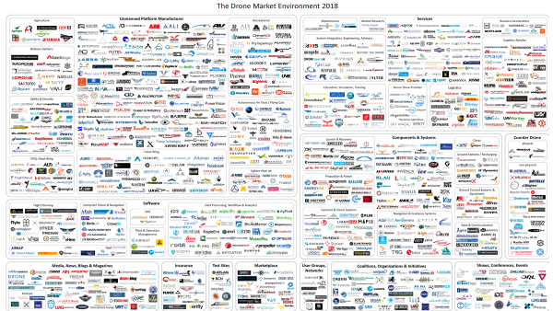

- Environment and Trends
  - Enterprise Drones: shipments will reach 805,000 in 2021, a CAGR of 51%
  - Industry in general operates is a disconnected Ecosystem
  - Lack of common knowledgebase/Customer questions on policy
  - FAA doesn’t address all legal and ethical issues/Lack of Rules enforcement
  - Part 107 License not inclusive of typical operational guidelines.
  - 2017: Over 170,000 Part 107 License Holders
- Drone High Growth Markets
  - Real Estate
  - Cell Tower and Utilities Inspections
  - Pipeline Tagging and Monitoring\
  - Agriculture and Farming
  - Construction / Engineering
  - Insurance Inspections
- Driving Drone Value Proposition and ROI
  - Improved monitoring in real-time/Communicating progress faster
  - Improved work-flow/Faster asset tracking
  - More accurate measuring
  - Catching conflicts sooner/Reducing downtime
  - Enhanced Safety / Identifying hazards and remedies
  - Analyzing Trends
  - Mitigate dirty, dangerous, dull jobs
- Barriers to Adoption
  - Public perception of drones
  - Availability of enterprise capital $
  - Lack of professionalism, training and best practice across industry
  - Limitations on operations (i.e. BVLOS)
- What will accelerate Growth?
  - Budget advocates across enterprise stakeholders
  - A PROVEN ROI model that can be articulated to stakeholders
  - Commercial Drone alliances (i.e. distributors, Associations)
  - Clearer routes to market (see example)
- Major Factors Driving Change
  - Increase communication across industry
  - Industry leadership
  - More clarity around regulations

- Routes to Market
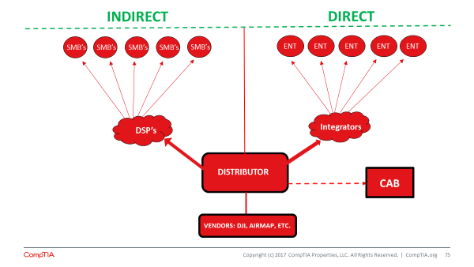
- Vision for next 3-5 years: Drivers having an Impact on Growth
  - National and State Policy alignment
  - Real Time Airspace Adoption
  - Positive Public Perception
  - State and Local Government Acceptance
- Goals for this Council
  - DSP’s (Drone service providers) to adhere to industry & data standards
  - Proven ROI
  - Identify clear routes to market (i.e.Channel, Associations, Distributors)
  - DSP’s to have comprehensive training and certification
- Connect Goals to CompTIA Goals
  - Proven ROI
    - Survey / Research / Include Academia
    - ROI Models on specific Drone applications (i.e. survey inspections, utilities, real estate, insurance, agriculture, etc.)
    - Create CompTIA ROI calculators for the identified applications
    - Package ROI calculators and push out.
    - Include Soft Targets: (safety, work-flow improvement, time cycle quality, analyzing trends, repeatability)
  - DSPs to have Training and Certifications
    - Survey existing training programs
    - Identify and collaborate with other associations
    - Educate & Train @ Industry events, user groups, media outlets
    - Identify Media Channels
    - Develop minimum set of standards for training programs
    - SEO to drive CompTIA website traffic
    - CompTIA (DRAC)- Drone Life Column
    - CompTIA (DRAC) LinkedIn Group

- Business Applications Advisory Council (BAAC) Report Out
  - Environment
        - SaaS is growing disparate from traditional IT
        - Increase in Line of Business decision making
        - Different route to market
        - Direct, App exchange, Marketplace, Channel
        - Customer differentiation through technology
        - Social, Mobile, Analytics, Cloud
        - Transient competitive environment
      - Barriers
        - Provider Issues
        - Lack of Skilled Resources
        - Gaps in consultative selling skills
        - Gaps deployment resources
        - Multiple routes to market
        - Complex Partnerships
        - Business Models & Pricing
        - Affiliate Models, Subscription, etc
        - Market Issues
        - Too many choices
        - New buying process
        - Micro Verticalization
      - Accelerators
        - New Buyers
        - Amazon Experience/Expectations
        - ADD economy
        - Technology Expansion
        - Consumerization of IT
        - App world, Mobile, Mass market of “one”
        - Internet Speed and Access - 5G
        - Time to Market Expectations
      - Goals for this Council
        - Increase trust between the SaaS and the IT community
        - Document the SaaS Sales and Implementation Process
        - Define SaaS sales, implementation and adoption roles
        - Build a customizable Playbook for selling SaaS
        - Vertical, Persona, etc.
        - Add your solution
      - Connect Goals to CompTIA Goals
        - This aligns with 3 of the 4 CompTIA industry council goals
        - Drive a better understand of SaaS ecosystem
        - Documenting the SaaS process to a set of standards
        - Educate and drive adoption of tech into mainstream business
        - All of this serves to grow IT businesses and careers
        - Driving the industry forward
      - Review Strategies
        - Document Process
        - Standardizing the process of selling and deploying SaaS
        - Create play book
      - Recommend Changes or Additions to Council
        - Add new diverse members
        - SaaS system integrator “Zapier”
        - Cloud SaaS distributor
        - Solution Provider
        - Vertical or Line of Business Developers or Solutions
        - Mobile, Voice Services, etc
      - Identify Methods to Measure Progress Against Goals
        - Understand buying patterns of Vertical Markets & Personas
        - Identify council members to participate in building process
        - Leveraging existing resources
        - Face to Face delivery
        - Industry events Road Shows
        - Tied to Channel Programs (optional)
        - Blogs, Social, adoption

- Channel Advisory Board (CAB) Report Out
- Trends
  - Vendors embracing the channel to access new markets but don’t know how
  - Unrealistic expectations in the channel - 6 months and leave
  - Integration is poorly understood with limited standards
  - Fiscal model is changing for partners; they are making less money than they've ever made
  - Vendor Product Brand preference is not as important to the customer
  - The definition of channel is changing (the trusted advisor is changing)
  - Increased use of consultants i.e. vertical markets, digital marketing, CPAs
  - Vertical communities are influential and continue to be a force
  - Moving away from a labeling a partner (one size does not fit all)
- End User Environment
  - Understand the job to be done - their business challenge and experience i.e. what outcome do they want e.g. drillbit example - sell the 1/4" hole not the drill bit
  - Line of business decision maker focused on achieving a business outcome
  - Product needs to work intuitively
  - Immediate access "amazon experience"
  - Access to support / questions - immediate (i.e. real time)
  - Continue shift from CapEx to OpEx
  - Security - assumption of all security
  - Real time ROI for technology investments (analytics, reporting, etc)
  - Instant scalability, used anywhere anytime
- Barriers to Adoption
  - The buyer's journey has changed. Customers are more savvy and could go direct
  - Vendors don’t know how to work with the service providers to get their product to a customer
  - Solution providers sales skills are weak and many lack vertical expertise
  - New trusted advisors may replace the traditional channel partner
  - Service providers that don’t adapt to a shifting customer demographic i.e who and how decisions are being made
  - Not understanding the profitability of the services offered
  - So many product solutions create confusion (App Store challenge)
- Accelerators to Adoption (How do we adapt?)
  - Define your value add and keep it fresh
  - Create specialization (industry, capability, etc)
  - Hire from industry to get vertical expertise
  - Platform revolution - create communities & leverage them
  - Embrace review systems (i.e. like an Angie's List)
  - Team with others (channel ecosystem – vendors, distributors, partners)
  - Build soft skills to discuss and communicate business outcomes
  - Protect the customer experience & focus on business outcomes
- Goals for this Council
  - Provide a Framework for all types of Partner to help define their Value add
  - Create a Platform that provides partners the ability to expand their skills and scope by working with one another.
- Connect Goals to CompTIA Goals
  - Understand emerging tech ecosystems (Partner Motions)
  - Build Industry Best Practice Standards (Skills Recruiting & Retaining)
  - Drive Adoption of Emerging Technology into Mainstream Business (Solutions & Emerging Technologies/ Cloud and Public Marketplaces)
- Strategies / Actions to Support Goals
  - Framework for developing a Value Add (Competitive Advantage)
  - Checklist of what needs & should be addressed/incorporated
  - Define your Mission as a first step
  - Ensure you keep it Fresh - Review and Update recommendation
  - Provide Route to Market Infographic to help in the positioning
  - Platform for Partnering
  - Spotlight on Skills (IT, Technical view)
  - Spotlight on Vertical Expertise
  - Spotlight on Business Process Expertise
  - Potential Score Teaming Activity based on Review by the participants?
  - Can CompTIA aggregate existing profile systems that exist?
- Other Goals & Strategies with CompTIA
  - Build a channel ecosystem infographic – define routes to markets, who & why
  - Build a ‘how to develop a successful channel program’ checklist
  - Define different types of IT service providers
  - Create content around building value-add into service provider practice
  - Define integration best practices
  - Define successful sales playbooks examples (Blueprints to learn)
  - Show a partner how they make money with a Vendor's product and how partners benefit Vendors
- Identify Methods to Measure Progress Against Goals
  - Value Add - Documents deliverable by ?
  - Sub Documents delivery dates
  - InfoGraphic/Route to Market - ?
  - Checklist Vetted and tested by CAB members - ?
  - Ecosystem Partnering
  - Assessment on ability to support/Implement

- Next Steps:
  - Dallas Working Meeting – Online Survey forthcoming
  - Next Steps / Asks & Actions / Debrief with Jim Meffert, CompTIA Staff & ACEB
  - Want to participate in a Council Video, Podcast, or Webinar – Sign Up with Chris Phillips
  - CompTIA Social Media Team – Council SLACK, LinkedIn / Facebook Sites?
  - Use the PR templates provided as a foundational basis and have Steve Ostrowski, Director Public Relations at sostrowski@comptia.org review your final press release before publication.

- Reminders
- Complete survey of Dallas Council Meeting
- Next Call: April 25th @ 1PM ET
- Update Profile in Speaker’s Bureau
- Send headshot, bio of 200 words or less, company logo, contact info for website by Friday, March 23rd to be included in Q1 update, otherwise, next Website update not until June.
- Look for invite from Maya for SLACK
- Look for Charity Selection 2018 email from Maya
- Check our Council Websites to ensure your personal profile and picture is updated, get with Maya on any needed edits.

- Respectfully submitted by Annette Taber, VP Industry Outreach

