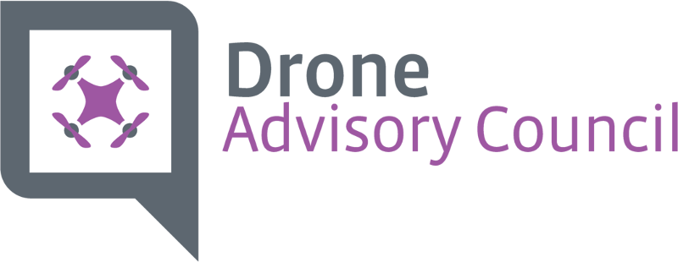
FLIP CHART NOTES – Spring Meeting, Dallas, TX
Questions to answer:
- Trends – Affecting Adoption
  - Lack of case study
  - Lack of standards
  - Disconnected ecosystems
  - Lack of knowledgeable
  - FAA Policy
  - Legal / guidelines
  - Local jurisdiction unaware
  - Part 107 Not Enough
  - Operations licenses does not exist
  - Enterprise integration
  - ROI Model / Budget Adoption
  - Customer Questions on Policy
  - Part 107 Confusion
  - Lack of Enforcement
  - Market Demand Increasing
  - Industry base segment privacy
  - Safety awareness / effect on prices
  - Enterprise play / competitor adoption
  - Formulizing channel
  - State & Local Government acceptance
  - Niche Players
  - Technology Eclipse Safety Regs.
- Vision for next 3 – 5 Years
  - To have impact on the further development
  - Real time airspace authorization
  - Positive public perception
  - National & state policy
  - Collaboration of Associations
- T.A.M – AEC
  - Utilities
  - Agriculture
  - Inspections
  - Insurance
  - Civil engineering
  - Search & Rescue
  - Public safety
  - Real estate
  - Geological / mining
  - Government
- What will limit Growth
  - Liability / Re-liability
  - Public perception
  - Lack of professional
  - Regulations
  - Lack of training
  - Stovepiping / tech standards
  - Budget advocate
  - ROI Model
- What will accelerate growth?
  - Budget Advocate
  - ROI Model
  - Proof of low TCO
  - Commercial Drone Alliances
- What are major factors driving those changes
  - Communication
  - Industry Leadership
  - Applicability
  - Availability of capital
  - Public safety incidence
  - Government action
  - Clarity around regs.
- Who will benefit
  - HW
  - SW
  - DSP’s
  - Public
  - Customers / Clients
  - Internal Use / Enterprise
  - Industry Sectors
- Goals for DRAC
  - DSP’s to adhere to Industry & Data Standards
  - Clear routes to market
    - Channel
    - VARs
    - Consultants
    - Associations
    - Distributors
  - DSP’s to have train / Cert options
  - Drones “R” Good!
  - Government Embrace
  - Enterprise funding / lifecycle mgmt.
  - Market demand
  - Proven ROI
- Strategies to Achieve Goals
  - DSP’s to have training & Certs
  - Survey existing training programs
  - Break into details, categories, etc. vertical markets
  - Identify & Collaborate with other vendors associations doing this work
  - Working to educate & train at industry events, user groups, media outlets
  - Identify media channels (AUVSI, Vendors)
  - Develop minimum set of standards – (for training programs)
  - SEO – to drive to website
  - CompTIA DRA – Drone Life Column
  - LinkedIn Group / SLACK
  - Simulators to test skill (DART Drones)
  - Train the trainer programs
  - Proven ROI
  - Survey – research (Include academia)
  - White papers – use cases Market Industry resources
  - ROI on specific Drone Applications
  - Identify & obtain various ROI data sets
  - Create CompTIA ROI Methodologies various applications
  - How to package ROI calculator & push
  - Research different ROI Models for each
    - Survey inspection
    - Utilities
    - Constriction
    - Real estate
    - Insurance
    - Agriculture
    - Public safety
  - Include – soft targets (safety, workflow improvement, time cycle, quality, repeatability, analyzing trends)
  - Business relevance of Drone Service
  - Be the “voice” of ROI become a ROI data clearinghouse
  - Clear Routes to Markets
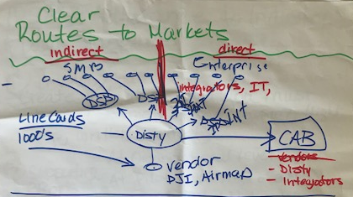

  - Survey number of IT integrators
    - Channel Primer for DRAC (education)
    - Training for TSP’s on ROI to them
    - Steps to integrate Drones into service portfolio
    - Checklist of partnering with DSP what to look for
    - Webinar for TSP’s
    - Quick start guide for DSP on how to build professional practice
    - Meet with CAB
  - DSP’s Adherence to Industry & Data Standards
  - Create & emphasize professionalism
  - Relevance of CompTIA
  - High likely hood of success!
  - Develop standards
  - Create check list of what you must have (statement of work, part 107, high logs, written contract)
  - Supporting efforts
  - At organizational level
  - At pilot level (code of ethics)
  - Push out the various pilot networks disty’s
  - Next level would include specific vertical standards
  - Training video to renew standards (why is this the standard)
  - Data Standards need transparency down to customers on what’s going to happen w/ data (usage standards, what’s used, what’s not)
  - Can CompTIA make investments to these organizations to support them?
    - AUVSI
    - OGC
    - Ag Gateway

