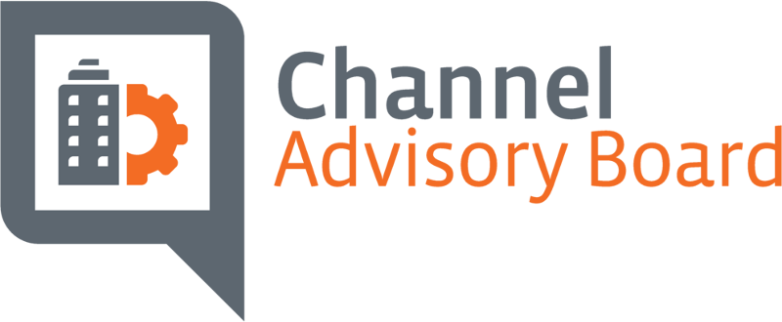
FLIP CHART NOTES – Spring Meeting, Dallas, TX
Define the Ecosystem
- Identify trends / Changes in customer need
- Define Channel By (Customer Needs)
- Build into tools that exist today
- Explore new avenues
Barriers to Adoption
- ‘S’ (Small) is not a bucket
  - There are Small user companies with more tech needs than some enterprise
- Partners sales and marketing skills are weak
- MSPs are selling on experience – not products
- Partner as the “expert generalist”
- Workforce
- Innovation – can be cost prohibitive to evolve your business
  - Partners need help from vendors with velocity to market
- Health of Channel
  - 5 years – 60% of partners plan to retire
  - Who is coming (Next Gen)?
- Buyer journey is totally different
- Decision maker has changed
  - LOB
  - Who owns the budget
- SMB – low or no security
  - Many unregulated
- Costumers are more savvy – going direct
  - Going around the channel
  - Staying in front of customers
- More vertical specialization needed
  - Size of company – GEO
  - Technology mix
  - Industry Type
- ‘S’ had different needs then ‘M’ and ‘E’
- Shadow IT
  - Security risk
- Consumer IT is driving IT decisions
- Traditional Partner problems are not working
  - “make partners better sellers” more successful
  - 3 – 5 year goal
- No SOP for MSP – CompTIA could do this
- Lack of collaboration in the Ecosystem
Trends
- Large companies moving into the channel
  - Telecom
- Collaboration between competitors on large contracts
  - Telecom especially
- The definition of “Channel” is
  - Changing – tech needs are out outpouring customer understanding
- The fiscal (billing / revenue) model is changing rapidly
  - Customer expectations / efficiency
- Increased use of consultants to map out strategy / connected vendors
Consequences
- Channel could get by passed
- Vendors could make it so ‘self-service’ that the channel may net be needed
- Easy to buy – con = hard to own
Time
- Labor shortage impact
- Business transformation
- Keep an eye on things that are getting better faster
  - Cheaper – the fastest
End User
- They need things to work
- Focus on end users and their experience
- Immediate access “Amazon expectation”
- Access to support / questions – immediate & real time
- Continue shift of CapEx to OpEX
- Security – assumption of Coverage on all Security (ie. Insurance)
- Real time ROI for technology investments
  - They want proof (analytics / reports, etc.)
- Understand the job to be done, their business challenge
  - What outcome do they want
  - Drill Bit example – sell the ¼ hole, not the drill bit.
- Ability to scale up / down – elastic
How do we adopt?
- Industry Specialization
  - Hire from industry
- Define your value add (Keep it fresh; why buy from me)
  - Need to create this framework
- Platform revolution
  - Communities
- Explore review systems (Angie’s List)
- Team with others
- Soft skills
- Vertical communities
- Financial guidance
Research
- Trends
- Increase our understanding of the trends
- Who are our customers
How
- How to adopt to changes
  - Culture
- Provide best practices to adopt
- What are the implications of tech changes to the culture of the company?
- Not tech for tech sake
- Solving the next big problem
- SAS / AI will tell us what the problem is
Slide # 1
- Trends
  - Identify key trends
  - Trends key paradigm shifts
    - End user influence
- Focus/ drill down on end user dynamics
Slide # 2 (Customer experience)
- Customer no knowledge
  - Knowledge
  - Unaware / education
- Reseller
  - MSP
  - ISV

